**Context:**

Welcome to GlobeMart, a leading fictitious e-commerce platform that has made its mark by selling a diverse range of products across multiple categories to millions of users worldwide. Founded in 2015, GlobeMart has experienced exponential growth, driven primarily by its customer-centric approach and a vast inventory of quality products sourced from thousands of vendors.

As a data analyst, you have been hired to dive into the vast pools of data accumulated by GlobeMart over the years to derive actionable insights, helping them enhance their business strategies. You will be working with data from different tables, each capturing unique facets of the business.

**Schema:**

* **Table: Users**

Contains information about the users, including their ID, name, email, signup date, and country.

* **Table: Products**

Contains information about the products available on the platform, including product ID, category, name, price, and stock count.

* **Table: Orders**

Contains information about the orders placed by users, including order ID, user ID (who placed the order), order date, and shipping date.

* **Table: OrderDetails**

Contains detailed information about each order, including the order detail ID, order ID, product ID (ordered), and the quantity of the product in that order.

**Structure:**

* **Users**: UserID, Name, Email, SignupDate, Country
* **Products**: ProductID, Category, Name, Price, StockCount
* **Orders**: OrderID, UserID, OrderDate, ShipDate
* **OrderDetails**: OrderDetailID, OrderID, ProductID, Quantity

**Entity Relationship:**

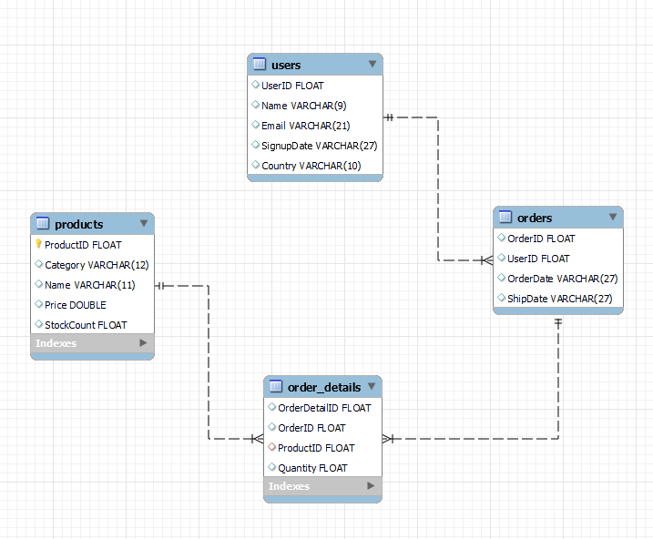

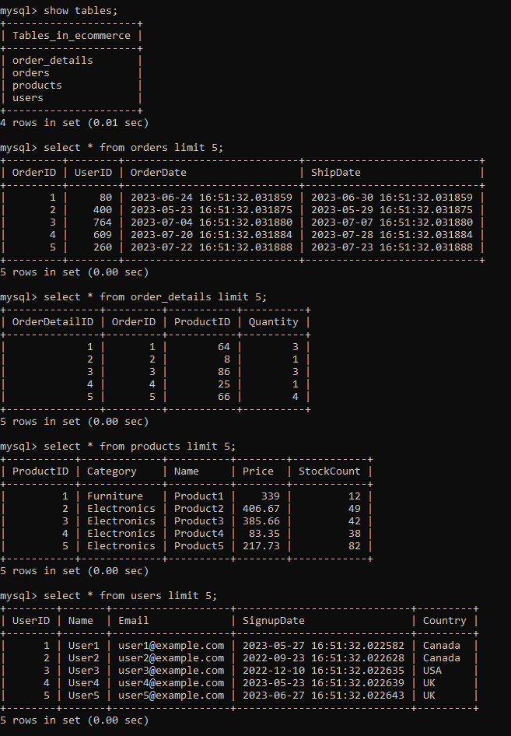

**Questions**

1. Extract the month and year from SignupDate and concatenate them to form a string like 'Jan-2020'.
2. How many unique product categories are there in the Products table?
3. On which day did the maximum number of users sign up?
4. How many products have never been ordered?
5. Find the number of users who have an email domain of "example.com".
6. Which product has the third highest price in the Products table?
7. How many users have never placed an order?
8. What is the average price of products in the 'Electronics' category?
9. How many orders contain more than 3 items?
10. Calculate the average price for each product category and label them as 'Expensive', 'Moderate', or 'Cheap' based on the following criteria:

* Average price > $300: 'Expensive'
* Average price between $100 and $300: 'Moderate'
* Average price < $100: 'Cheap'

1. For each user, retrieve the date of their first order and their most recent order. Which table would you use and how would you construct the query?
2. For each order, identify the product with the highest quantity. Which tables would you use and how would you construct the query?
3. For each product category, retrieve the 3rd most expensive product's ID. Which tables would you use and how would you construct the query?